

Tambareni Academy  www.Tambareni.com | Business Requirement Document (BRD)  A Patient Portal Management software

Project: Manage My Patient (MMP)

Client: North America Medical Technology Group (NAMTG)
www.NorthAmericaMedTechGroup.com

Date | Version | Description | Author /  Developers
04-02-2015 | 2.0 | All modules related to MMP application | Rao Tambareni  Meena  Mona  Hema

Table of Contents
1. Introduction
1.1 Purpose of this document
1.2 Intended Audience
1.3 Scope
2. General overview
2.1 Technologies used
3. Technical requirement

Introduction

Purpose of this document

Intended Audience

- Business Analyst
- QA Tester
- QA Test Lead
- QA Manager
- Developers
- Project Manager
- Technical Architect
- System Engineers
- Configuration management team

Scope
Limited to the requirements given in this document.

General overview

Technologies used

Manage My Patient is a web based application. We used MySQL, Dream viewer, Apache server, PHP and Web services. The technologies and component are open source.

Technical requirement

5. SYSTEM FUNCTIONS

5.1 All Use Case Overview:

Patient
- Register Account
- Login Account
- Edit Profile
- Load Homepage
- Schedule Appointment
- View Information
- Pay Fees
- View Reports
- View History
- Edit Form
- Send message
- Search Symptoms
- Change Language
- Update Forms

Admin
- Register Account
- Login Account
- Users
- Edit Account
- Submit Claim
- View Claim Status
- View EREMITTANCE
- Enter Payments
- View Patients
- Search Patients
- Add Patients
- Create Visit
- Add Prescription
- Create Fee
- Add Report
- View Current Report
- View Report History
- Indicate Availability
- Answer Messages
- Contact Support
- Load Homepage

Doctor
- Register Account
- Login Account
- Edit Account
- Add Prescription
- Edit Reports
- Load HomePage

Insurance Provider
01 Register Account
02 Login Account
03 Logout Account
04 Search
05 Approving this is just a place holder, pls change / add these titles .. )

Admin Module

Use Case Name | Register Account as Office Administrator
Use case ID | ADM001
Use Case Description | Functionality allows office admin to create a new account by entering specified details.
Flow of events: Happy Path

Actor |  | System
ADM001.1: Home page URL  Example:  http://<IPAddressOfServer>/<MMP-Build Number> |  | ADM001.2: System shall display default home page with following:  Home, Patient Login, Office Login, About Us Contact Us tabs across the top  Refer: Mockup screen  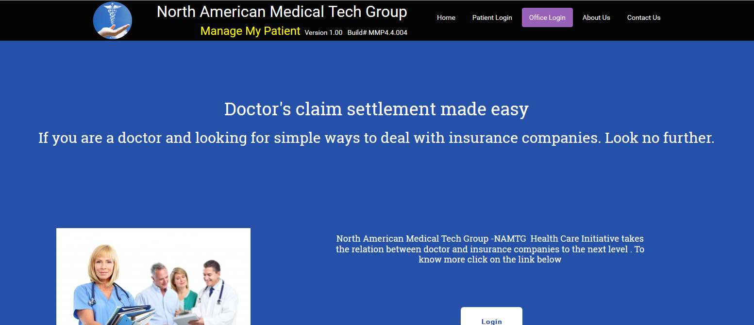
ADM001.3: Administrator can click on the register button on the Login screen  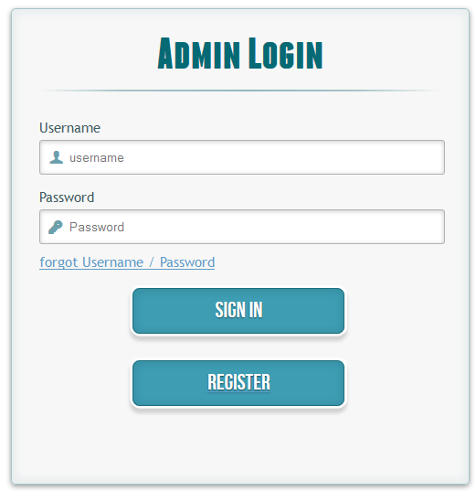 |  | ADM001.4: Office Administrators can register with following fields.  - First Name – required field  - Last Name - required field  - User Name - required field - max 10 characters without any special characters/blank spaces  - Password - required field - max 6 characters with at least one numeric and one uppercase and should not include blank spaces.  - Confirm Password - required field and match with the password field  - Office Code - required field (How to get the office code?)  - EMAIL ID  - Save Button  Verify if the user is able to register and navigates to the Admin login page after system confirms “Admin Registration Successful” Message.  Refer: Mockup screen  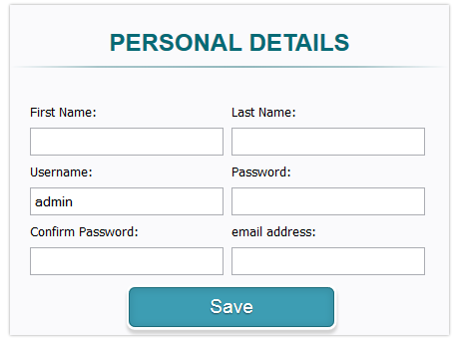
Flow of Events: Alternate Path

Actor |  | System
ADM001.5: If Admin enter invalid values in each field for registration page and click “save” |  | System should display error message  - Please enter first name  - Please enter last name  - Please enter password  - Pease enter confirm password  - Please enter office code  - Please enter valid email id  If the password and confirm password didn’t match, error message is “Please enter same value for both password and confirm password fields

Use Case Name | Login as Admin
Use case ID | ADM002
Use Case Description | This use case describes how to login as administrator to MMP application.
Flow of events: Happy Path

Actor |  | System
ADM002.1: MMP Home page, Office Login, Click Login for Admin Login window. |  | ADM002.2:  Login window contains following fields / hyperlinks.  A)Username : required field to enter valid registered user name  B)Password : required field to enter valid password  C) Hyper link : forgot Username / Password :  D)SIGN IN Button  E)REGISTER Button  After Login : Administrator home page should display with  - Home: with patient list  - Users:  - Claims Center  - Patients  - Indicate Availability  - Messages  - Logout  Reference Mockup screen for Admin home page after login as admin  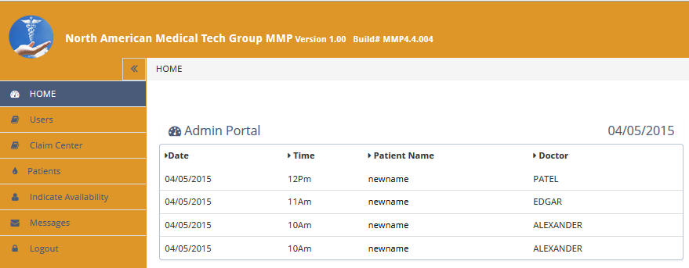
ADM002.3:  Hyper link: forgot Username / Password |  | Should take the user to enter the email id to recover the password by entering the registered email ID. If The user enter valid email id and click Send, User receive an email with password.  Refer mock up screen for Forget password  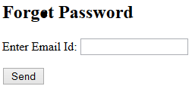
Flow of Events: Alternate Path

Actor |  | System
ADM002.4: Enter invalid admin login id and password |  | If blank user id or password, “Please fill out this field”  If invalid username or password: error message should popup.  “Wrong username and password.”  Refer: Mockup screen #  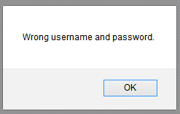
ADM003 This use case describes on what can be done once logged in as Admin
After Login : Admin home page should display the following  - Home: With appointment list  - Users: With Patients List  - Claims Center: With search Patient option  - Patients  - Indicate Availability  - Messages  - Logout |  | 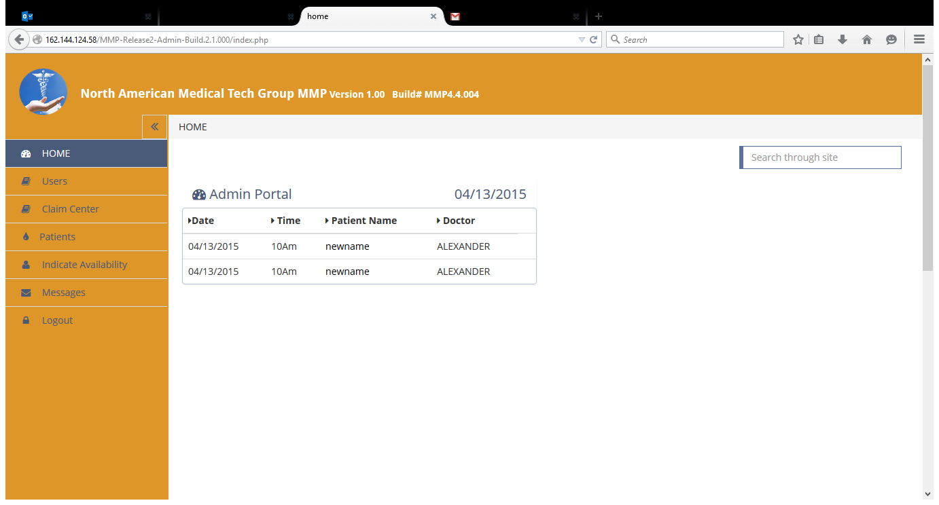

Use Case Name | Users Tab for Admin
ADM003.1 | ADM003.1
User should get navigated to the Search patient by status page when click on USERS tab. | This use case describes how to select/change/upgrade the status to Accepted/Pending/Rejected from the dropdown menu of Status.  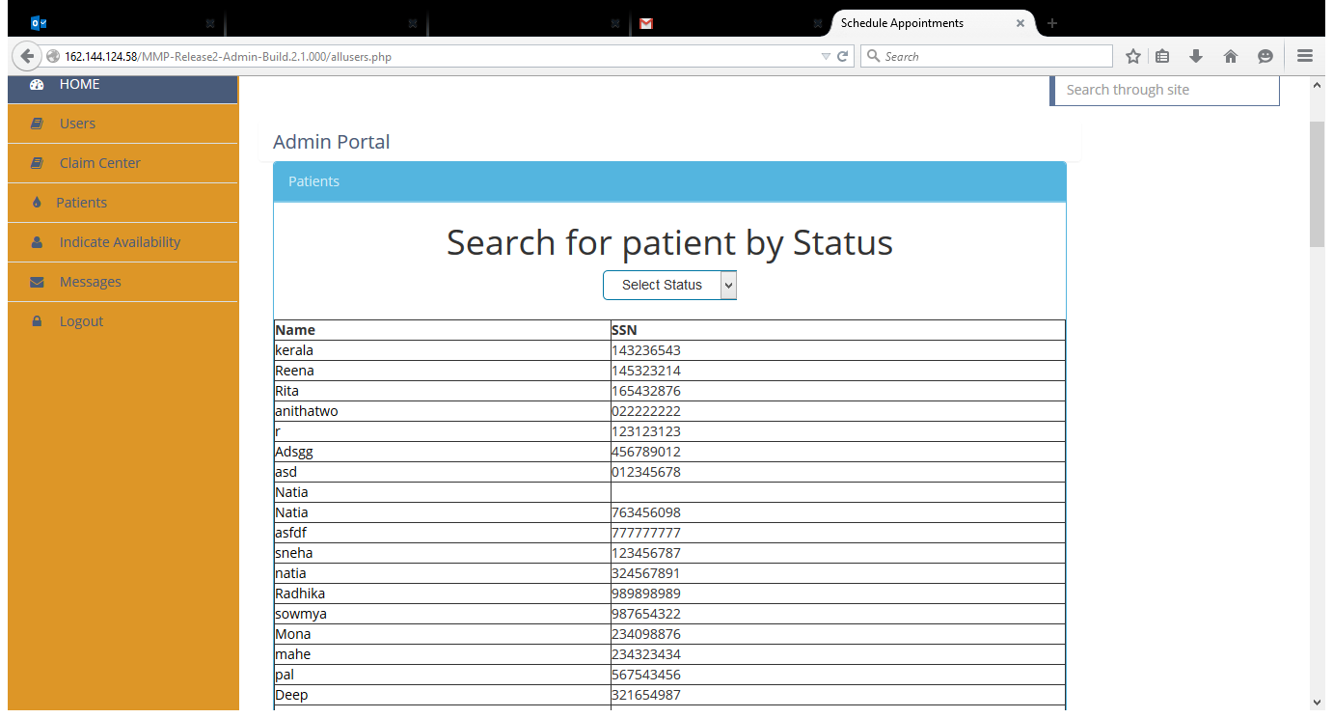
ADM003.2 |  | Select Claims Center Tab for Admin
ADM003.2
User should get navigated to the Search Patient by Name, SSN page when clicked on Claims Center Tab. |  |  | 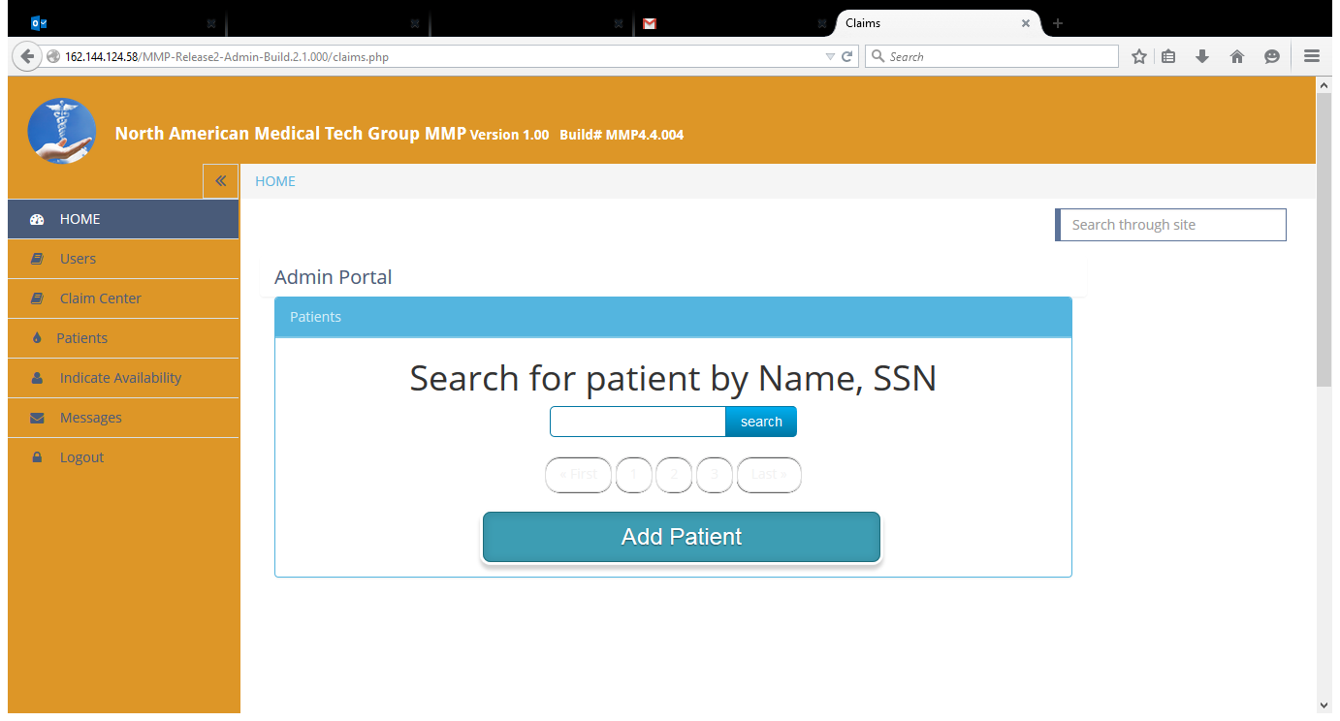
ADM003.3  Insert the Name or SSN of a patient to see the list of patients with the name given. |  |  | 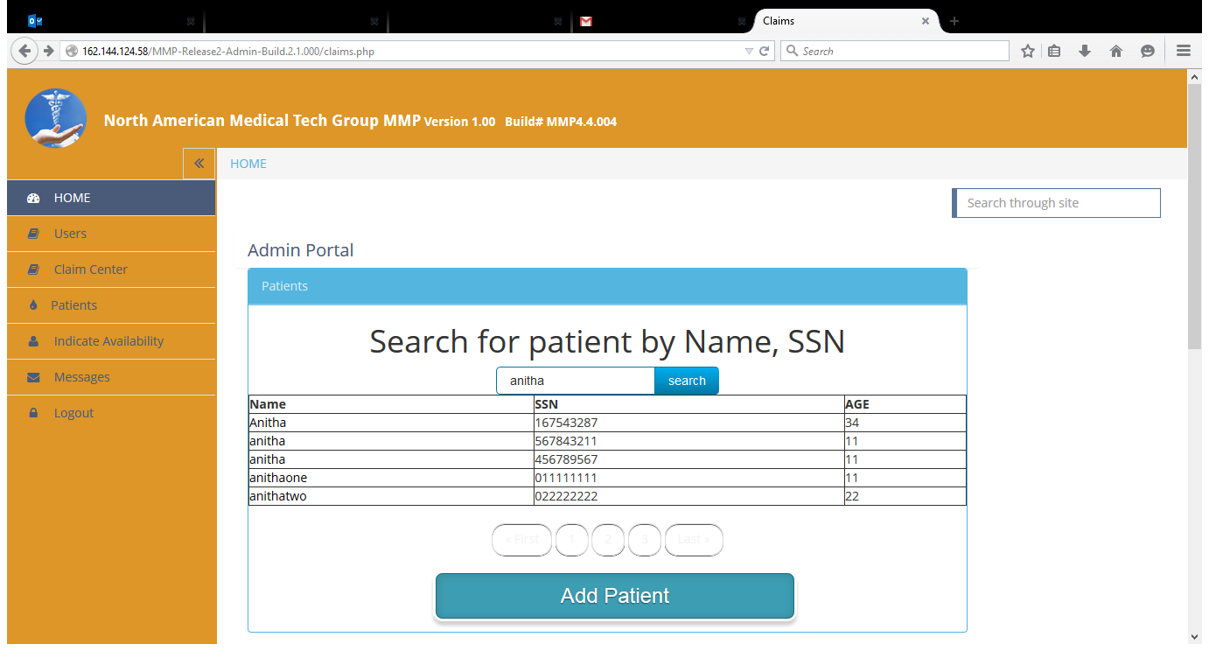
ADM003.4  Click on the Patient name to check the detailed page of Submit Claims |  |  | 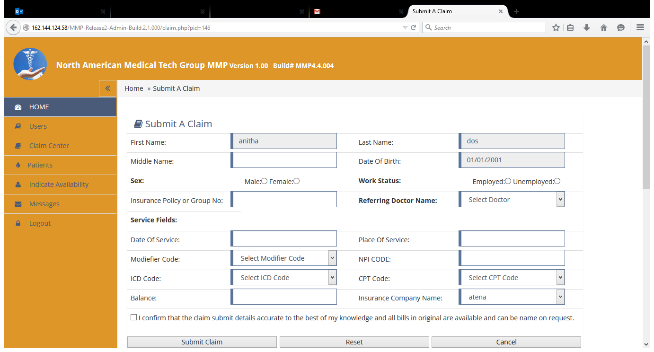

Use Case Name | Validating the Submit Claims Page for Admin
ADM004 | ADM004.1
This describes the details of the Submit Claims page | This use case describes how to validate the fields on Submit Claims page for Admin.
Flow of events: Happy Path

Actor |  | System
ADM004.1  Insert all the valid credentials for the Submit Claims page in order to Submit the Claim.  The Modifier Code  The NPI Code  The CPT Code  The ICD Code  All these codes should be selected from the dropdown menu respectively.  Select the CHECKBOX after filling out the form. Click on Submit Claim. User should be able to insert the Claim successfully.  “INSERTED” should display below the Submit Claims on the page. |  | 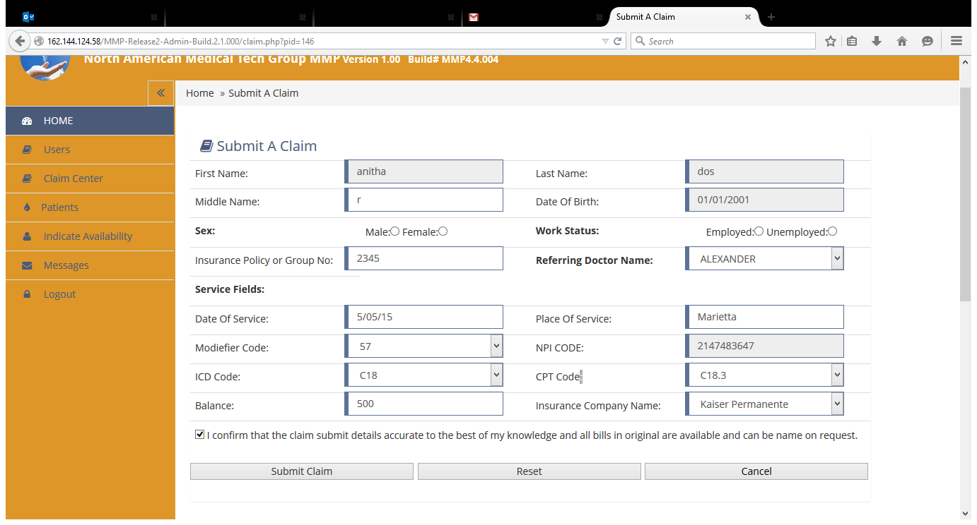  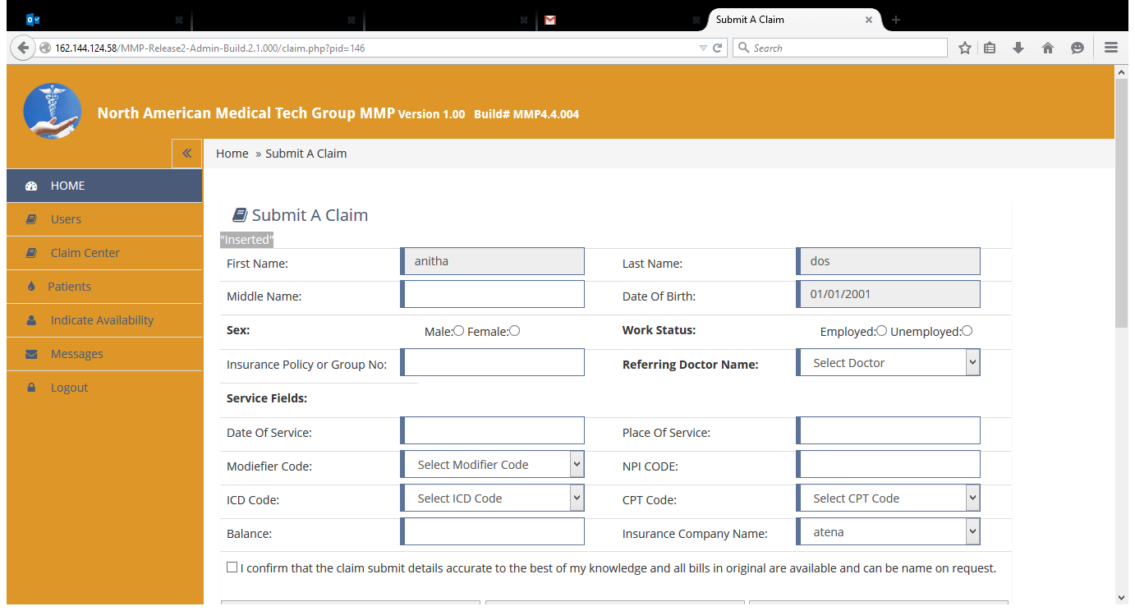
Flow of Events: Alternate Path

Actor |  | System
ADM004.2  Insert all the invalid credentials for the Submit Claims page fields.  Error messages should be displayed for each field when invalid data is entered. Along with a pop up window displaying ”Terms Rejected. Cannot Proceed…” |  | 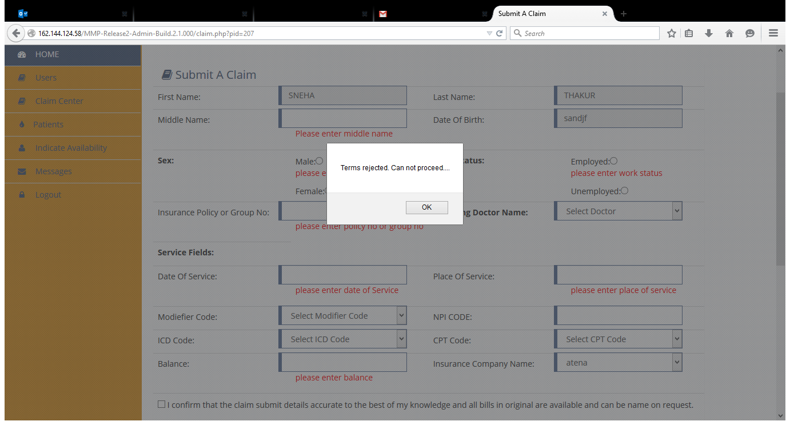

Use Case Name | Patients tab for Admin
ADM005 | ADM005.1
This use case describes how the Patients tab works for Admin | Description on how to validate the fields of Patients tab for Admin
Flow of events: Happy Path

Actor |  | System
ADM005.1 Click on Patients tab, the user should get navigated to the Search Patient by Name, SSN page with search button |  | 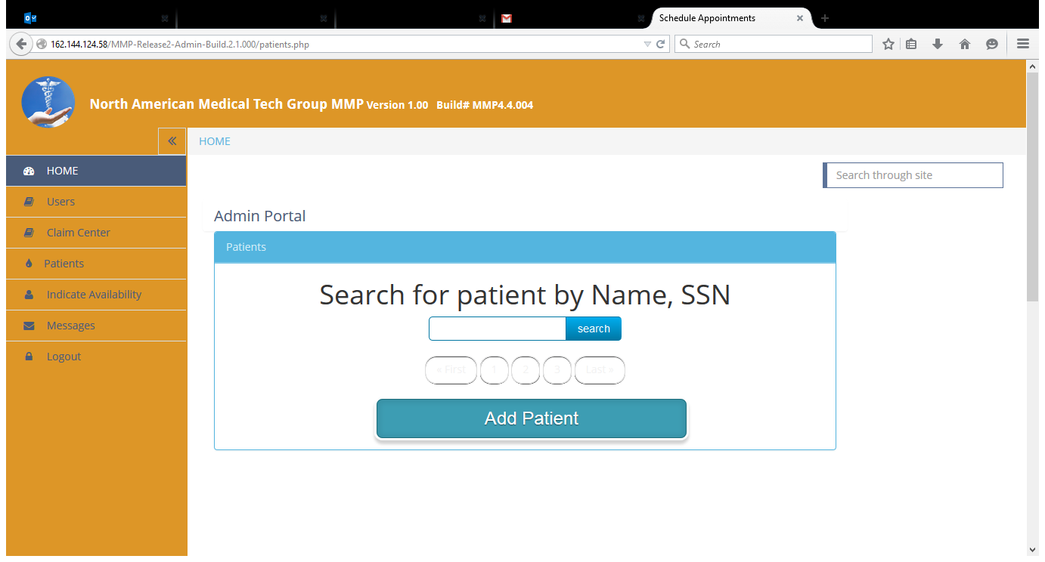
ADM005.2  Click on the Patients name after entering the patient name and clicking on search button.  User should get navigated to the page with following  1.Create Visit  2.Add Prescription  3.Create Fee  4.Reports |  | 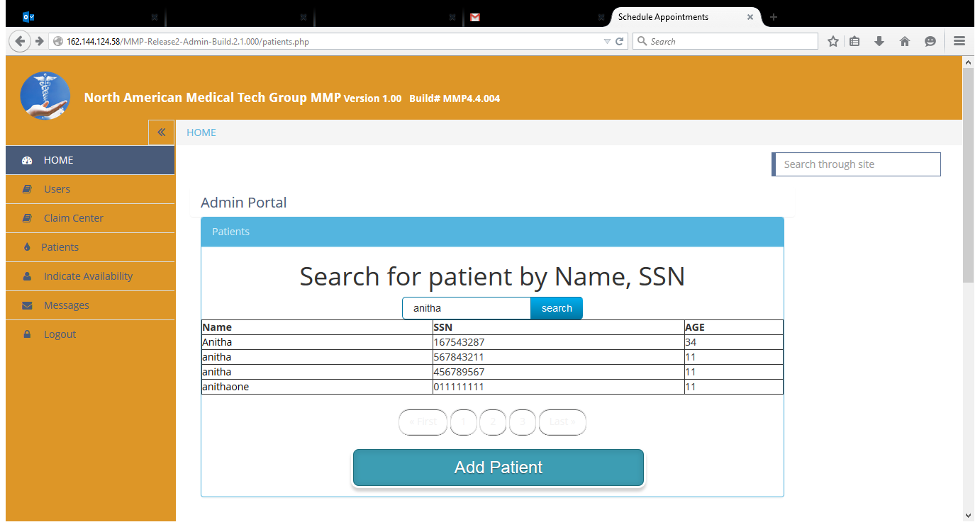  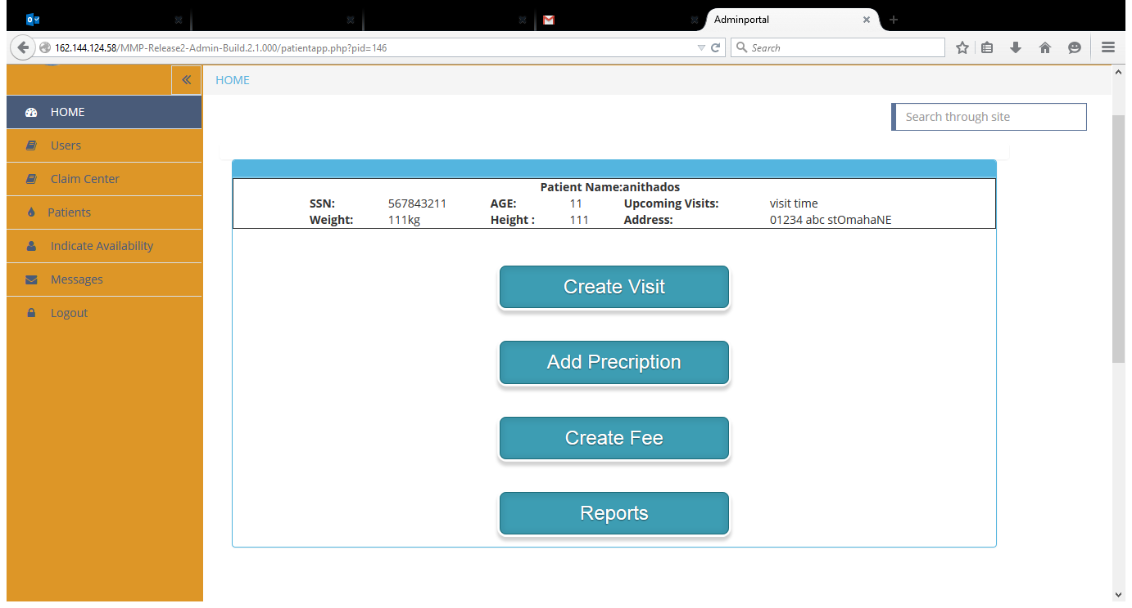
ADM005.3  1. Click on the Create Visit tab to book an appointment with the list of doctors.  2. Click on Book Appointment, user should get navigated to a popup window with Date, Time details.  3. Select the Date, Time and click on Continue button.  4. Page with Symptoms for the patient is displayed.  5. Insert the details of symptoms and click on Submit button.  6. User gets navigated to the Patients tab homepage. |  | 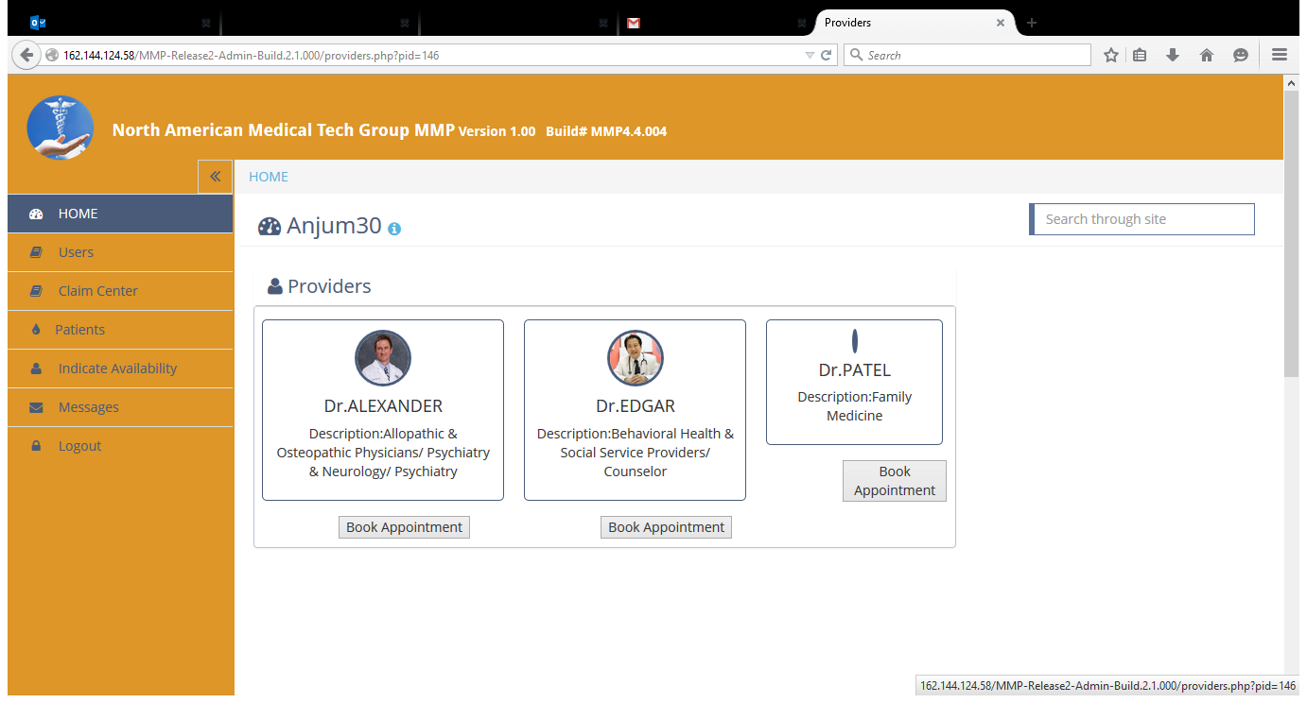  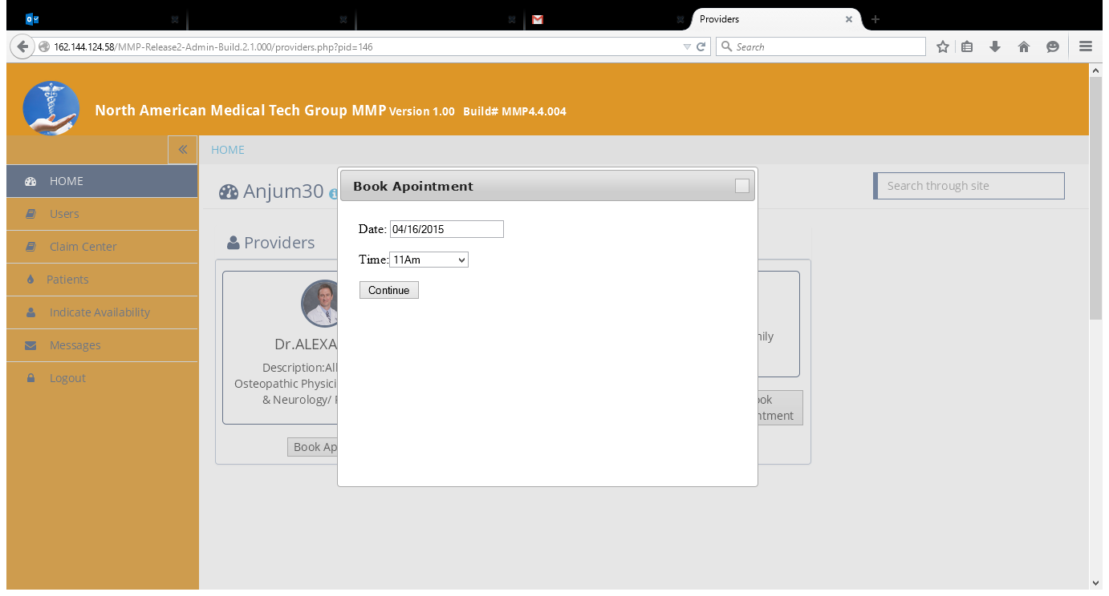  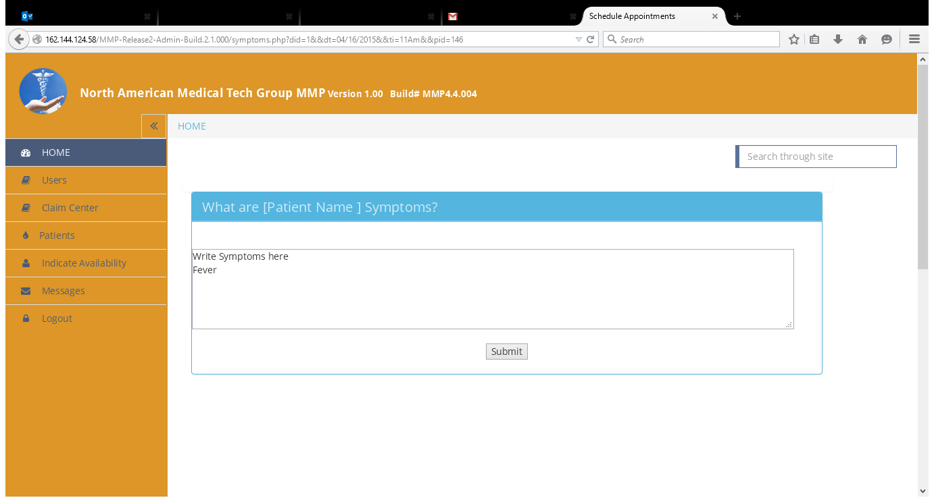
ADM005.4 Click on Add Prescription tab to select the prescription details and click on submit button.  “Prescription is added” message displays. |  | 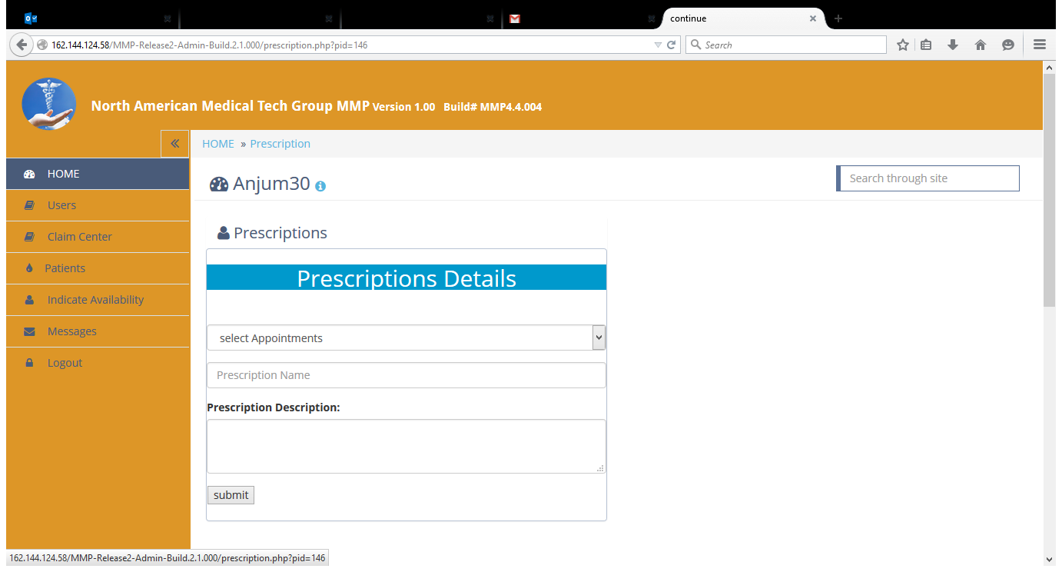  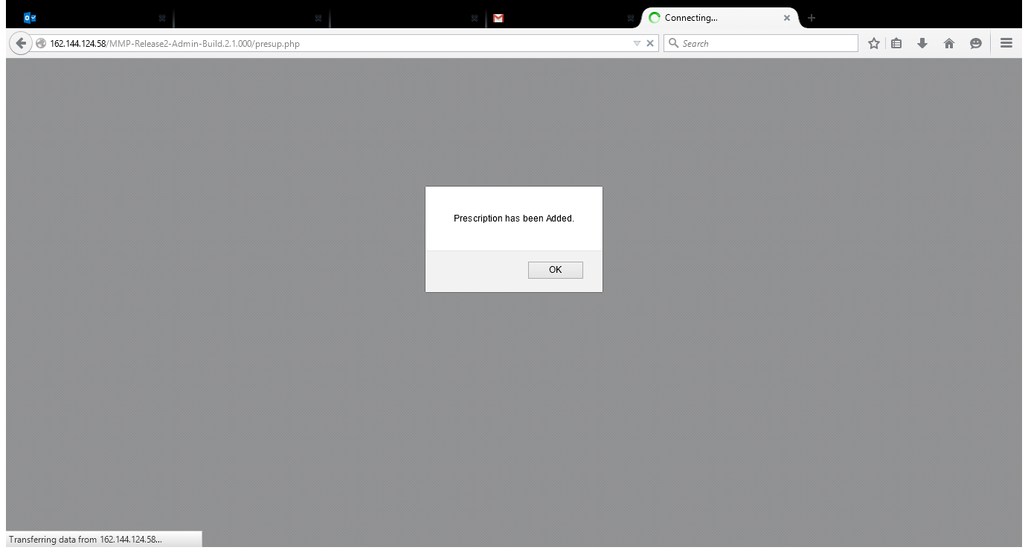
ADM005.5  Click on Create Fee tab, User gets navigated to the Fee page.  Select the Appointment, Service from the drop down menu, the Fee field gets auto populated and click on submit button.  “Fee Successfully Entered” message is displayed. |  | 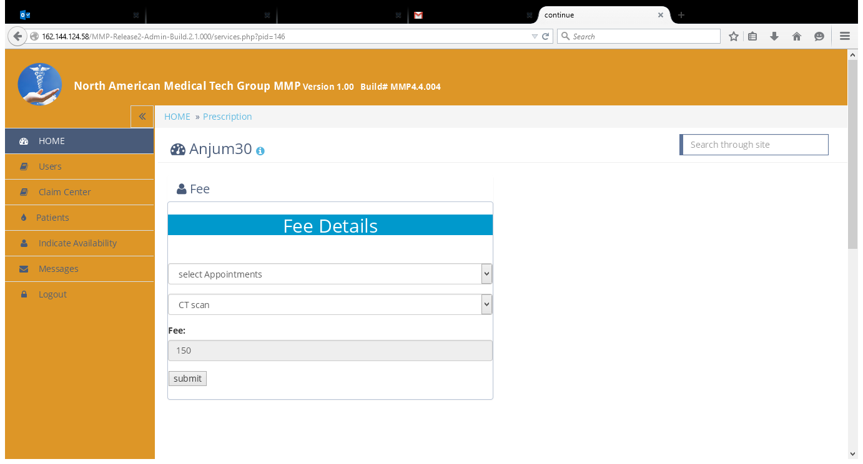  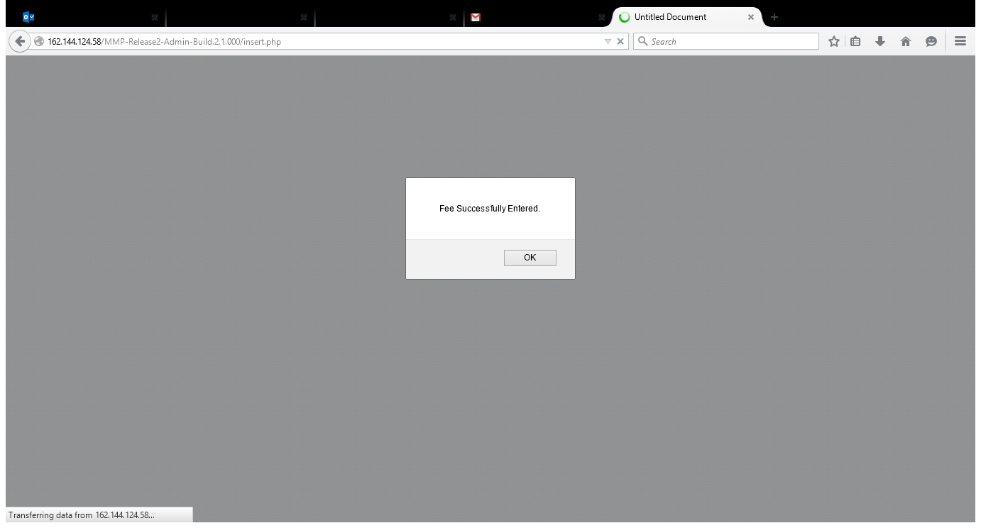
ADM005.6  1. Click on Reports Tab, User gets navigated to the Reports Details page.  2. Select the appointment, Scanned Report (if any) and write down the description related to report and click on Submit button.  3. User gets navigated to the Patients Tab homepage. |  | 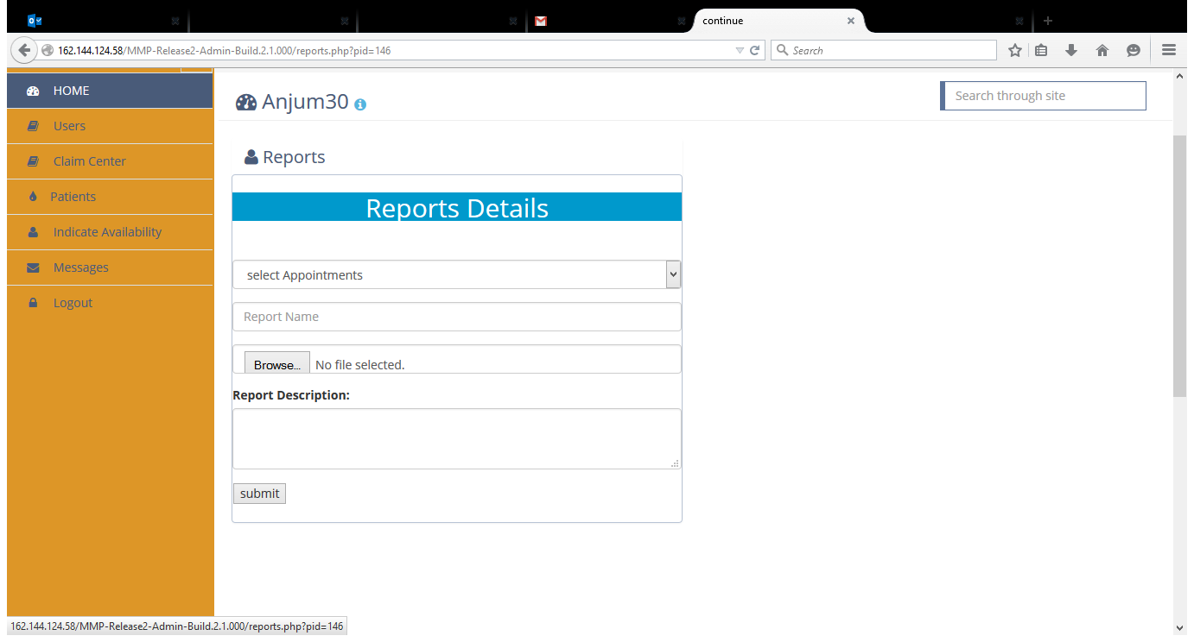

Use Case Name | Messages Tab for Admin
ADM006  This describes the Messages tab | ADM006.1  The Use Case describes how the Messages tab works for the Admin
ADM006.1  1. Click on the  Messages Tab, User gets navigated to the messages page with Patient Name, Reason, Date. | 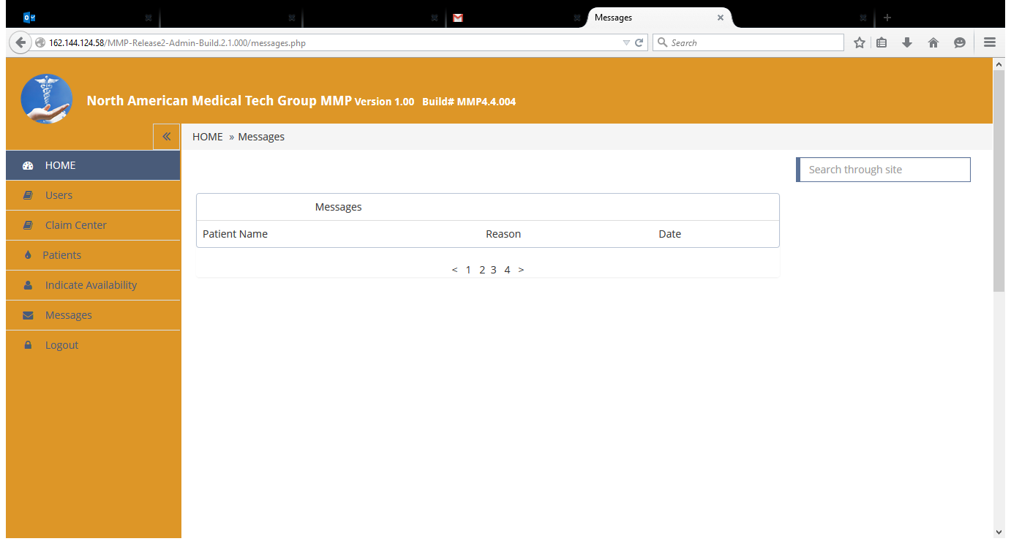
Use Case Name | Logout Tab for Admin
ADM007 | ADM007.1
This describes the Logout Tab | The use Case describes how the Logout Tab works for Admin
Click on the Logout Tab, User gets logged out of the app and gets navigated to ADMINLOGIN page. | 